**Overview**

This project demonstrates a 3-tier cloud-native web application deployed on Amazon Web Services (AWS). It collects user information (Name, Email, Phone) through a frontend web form, processes it at the application layer, and stores it securely in an Amazon RDS MySQL database. The architecture was built entirely from scratch, incorporating high availability, scalability, and security best practices using AWS services.

**Services Used**

* Amazon VPC – Custom VPC with public and private subnets across multiple Availability Zones.
* Amazon EC2 – Web servers hosting the frontend application (Application Tier).
* Amazon RDS (MySQL) – Database for securely storing customer information (Database Tier).
* Amazon EFS – Shared file storage for application servers.
* Elastic Load Balancer (ALB) – Distributes traffic across EC2 instances.
* Auto Scaling Group – Dynamically adjusts EC2 instances based on demand.
* NAT Gateway – Provides outbound internet access for private subnet resources.
* AWS Certificate Manager (ACM) – Manages SSL/TLS certificates for HTTPS.
* Amazon Route 53 – DNS and domain management for the application
* Amazon SNS & EventBridge – Monitoring and notifications.
* AWS IAM – Fine-grained access management and security.
* Bastion Host (Jump Server) – Provides secure administrative access to private instances; accessible only through SSH within the organization’s network.

**Key Features**

* Scalable – Auto Scaling Group ensures the application grows with demand.
* Highly Available – Multi-AZ deployment with Load Balancer for fault tolerance.
* Secure Access – Bastion Host for private instance management and NAT Gateway for controlled internet access.
* Encrypted Communication – SSL/TLS certificates managed via AWS Certificate Manager
* Custom Domain Integration – Route 53 provides DNS and domain-level routing.
* Separation of Concerns – 3-tier architecture isolates frontend, application, and database layers.
* Monitoring & Alerts – SNS and EventBridge for proactive notifications and automation.

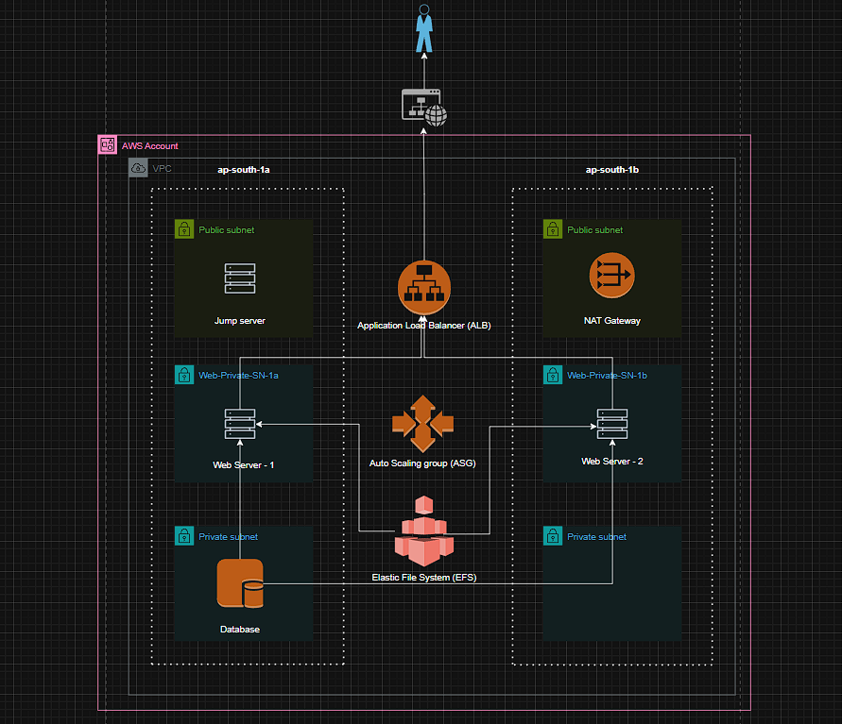**Diagram**

**Project Snapshots**

* 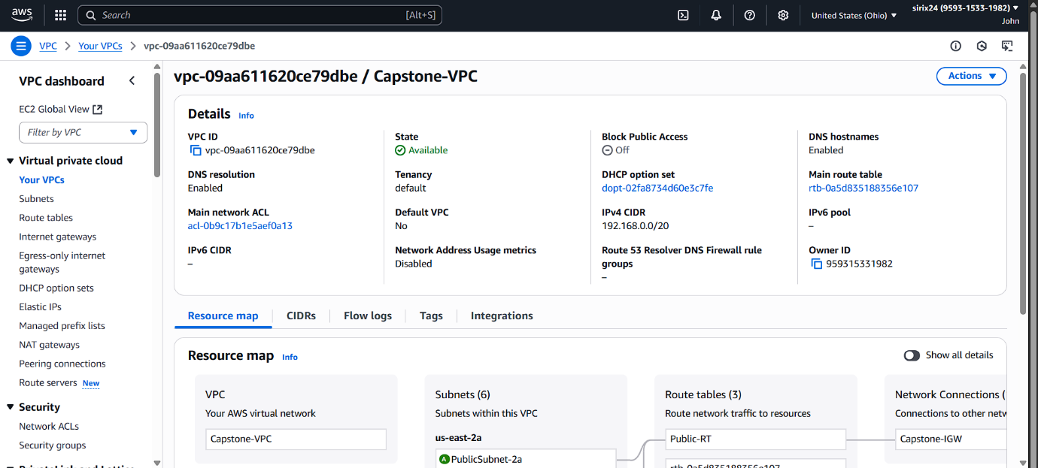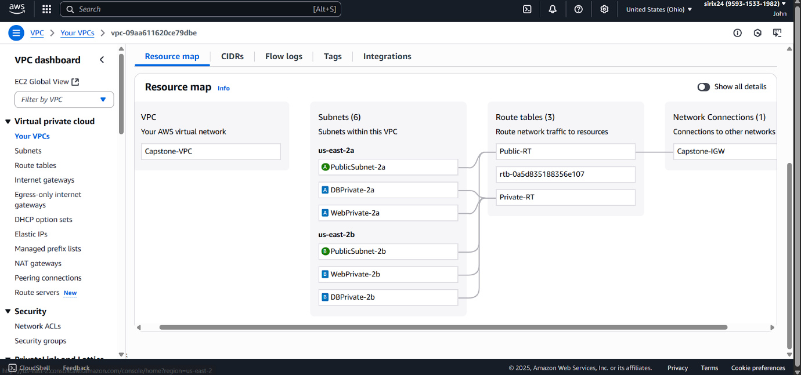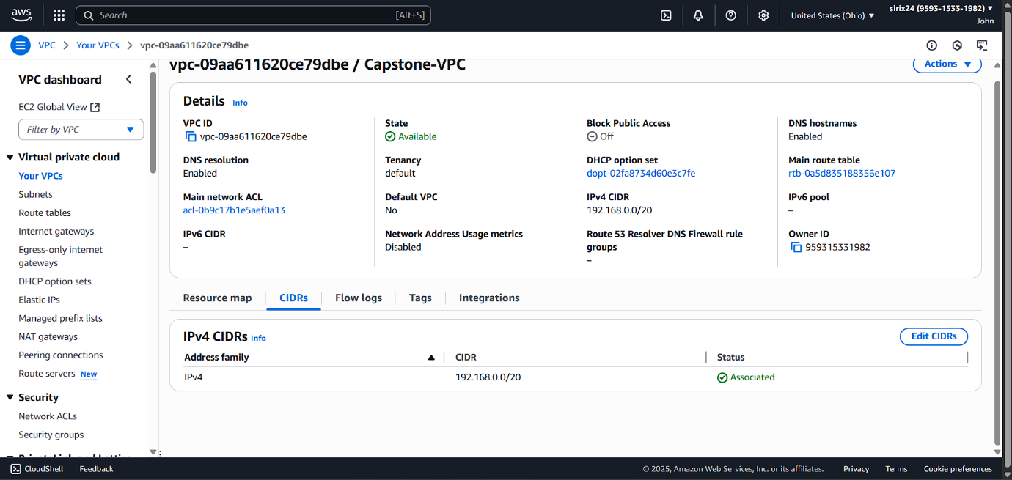Built a VPC with 2 Public and 4 Private Subnets, providing ~4,091 usable IPs for secure and scalable networking.
* 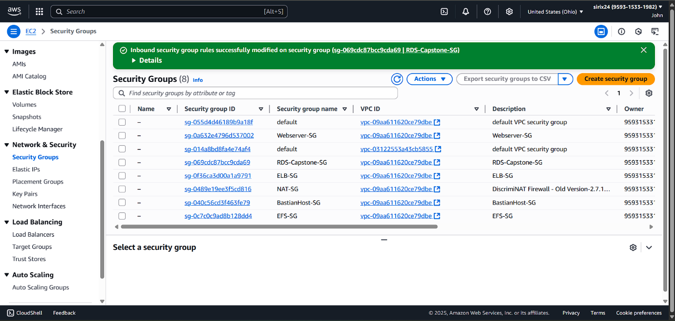Configured Security Groups for Web, Application, and Database tiers to enforce tier-wise isolation and secure communication within the 3-Tier architecture.
* Built a base EC2 instance, hosted the web app, and created an AMI to enable Auto Scaling deployment.

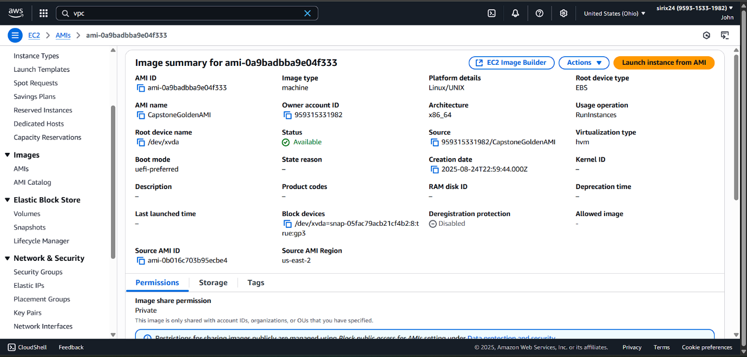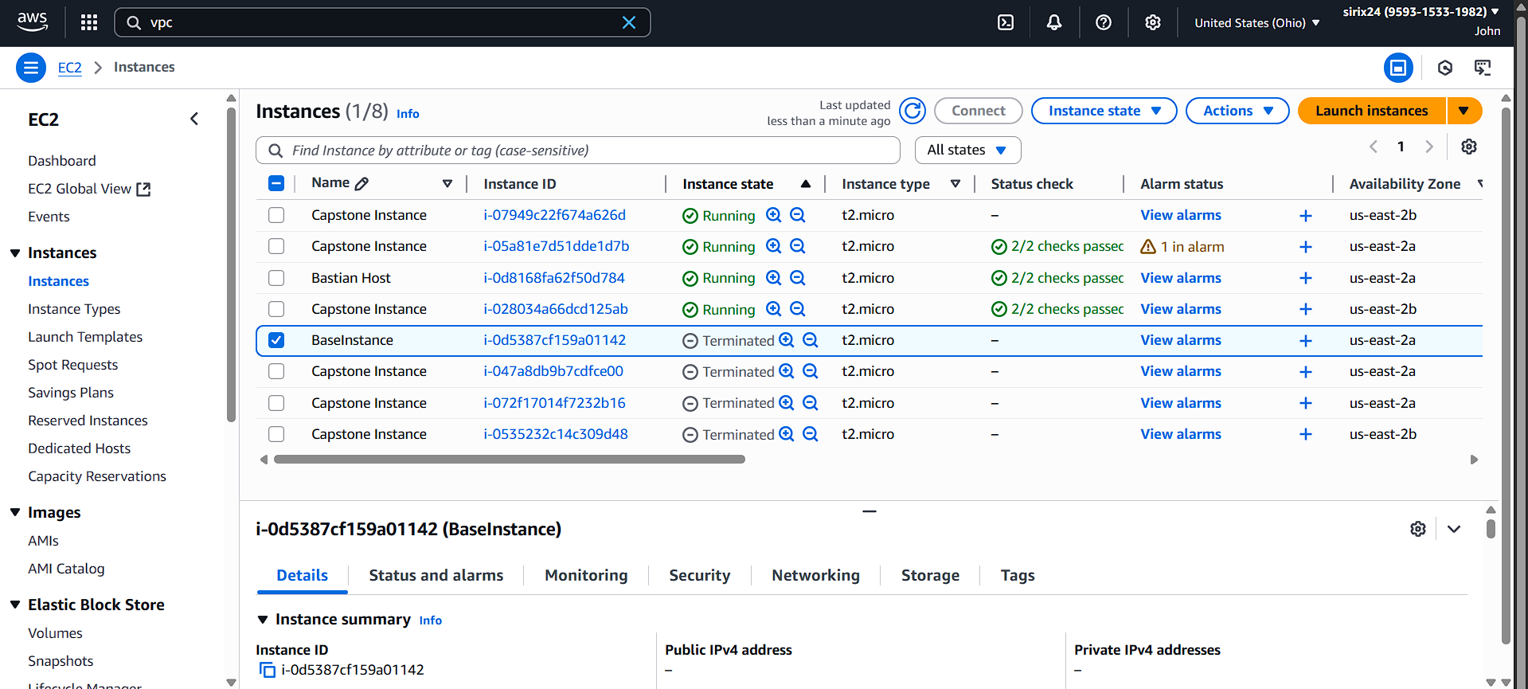

* Provisioned multi-AZ Private Subnets to host database instances with high availability.

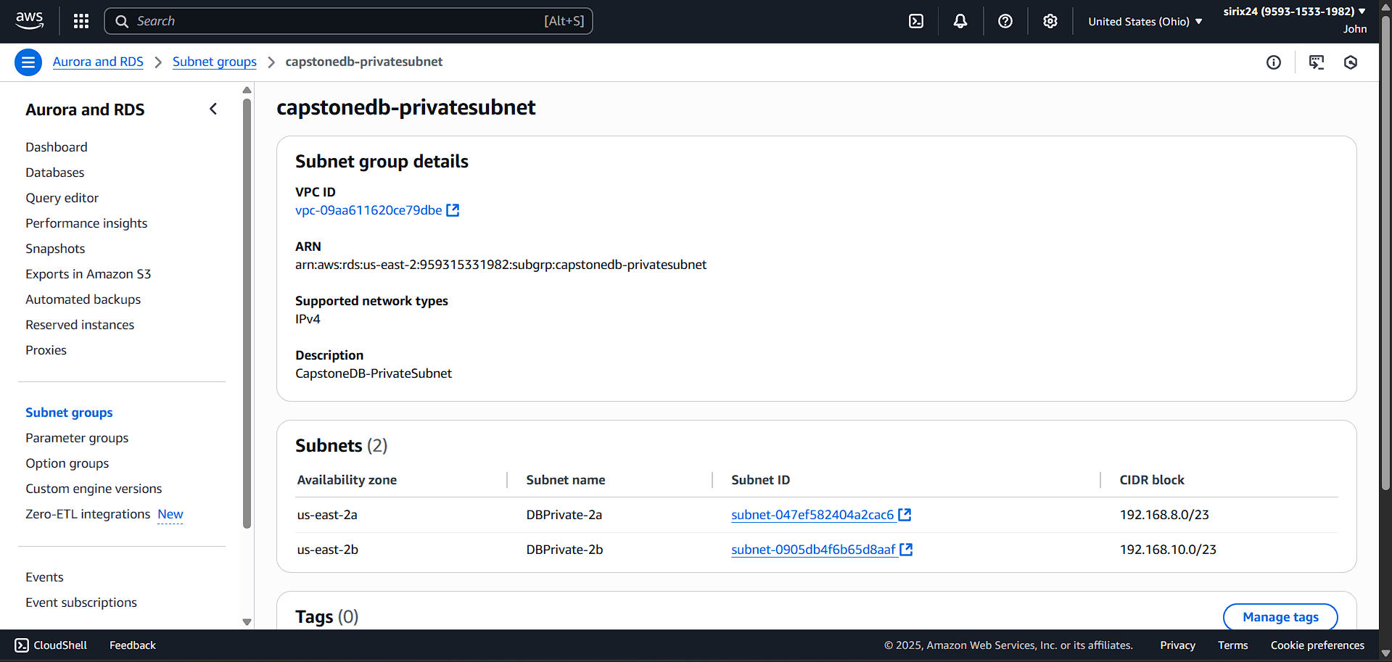

* Provisioned a MySQL RDS in the Private Subnet for secure database hosting.

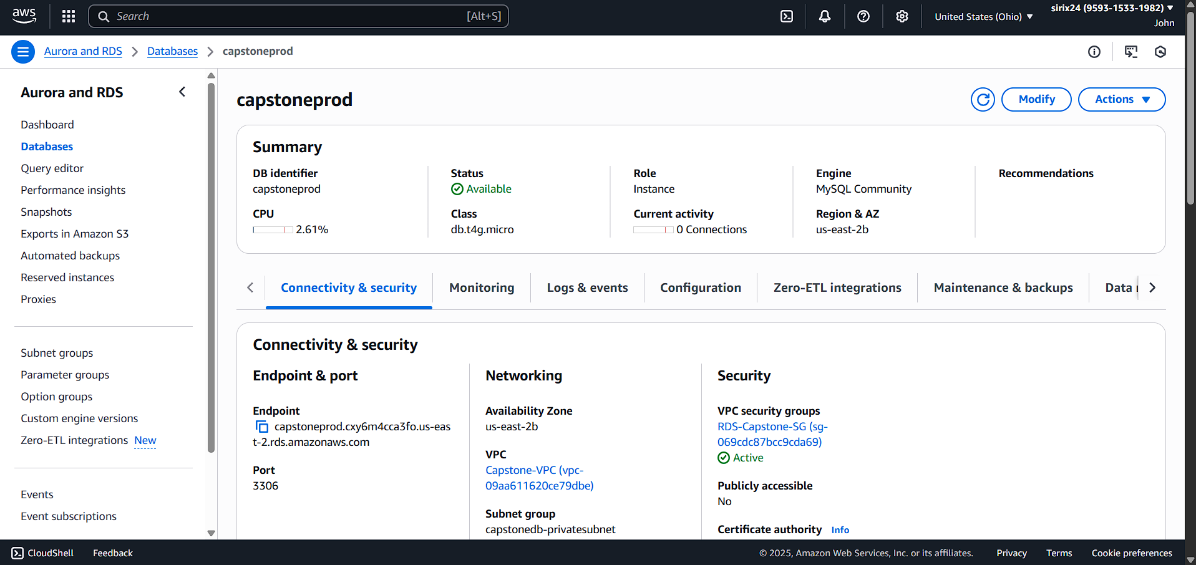

* Configured an Elastic File System (EFS) and mounted it to the base instance to enable scalable shared storage

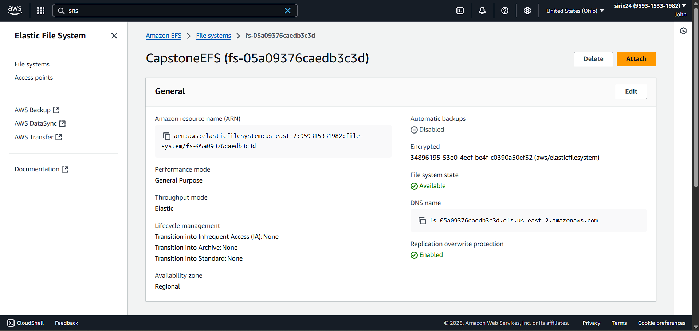

* 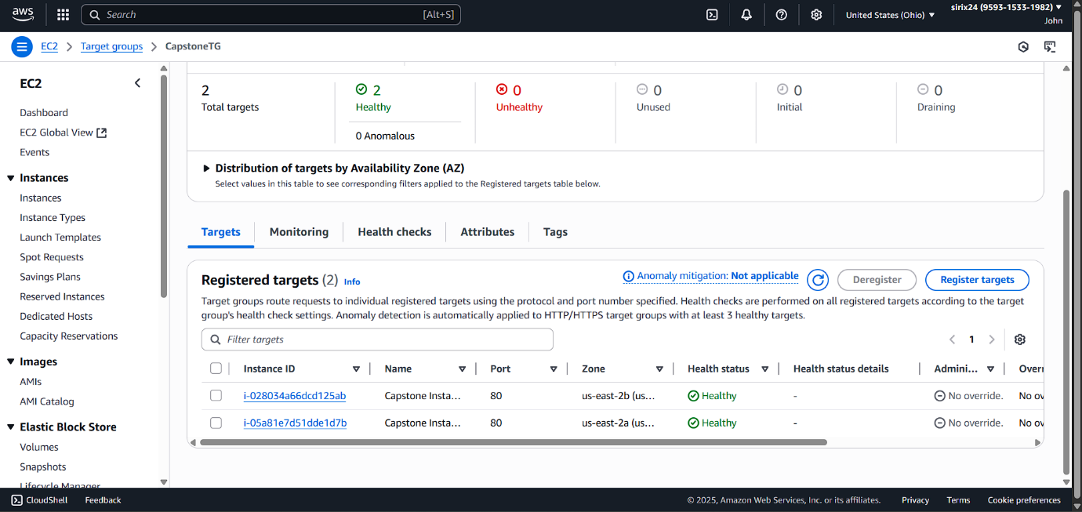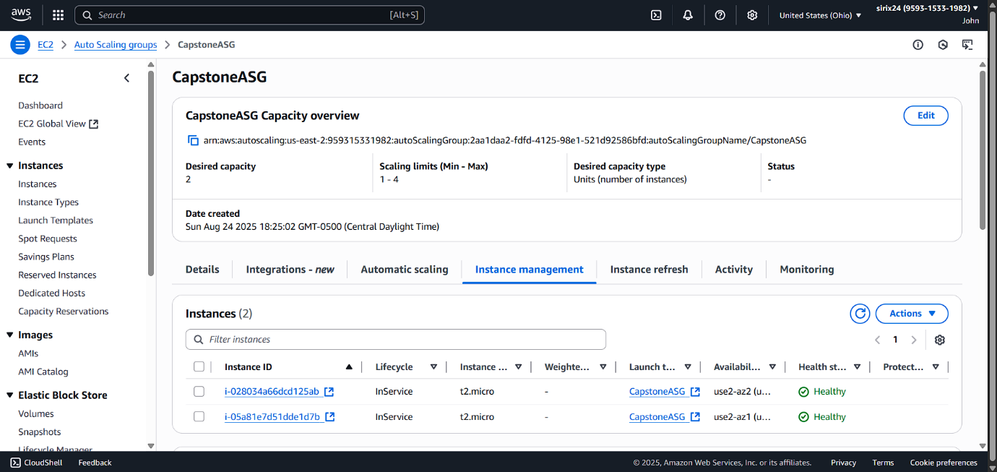Created a launch template and configured it to Auto Scaling Group(ASG) to ensure scalability.
* Created and configured an Application Load Balancer (ALB) to efficiently distribute incoming traffic across multiple instances, ensuring high availability and fault tolerance.

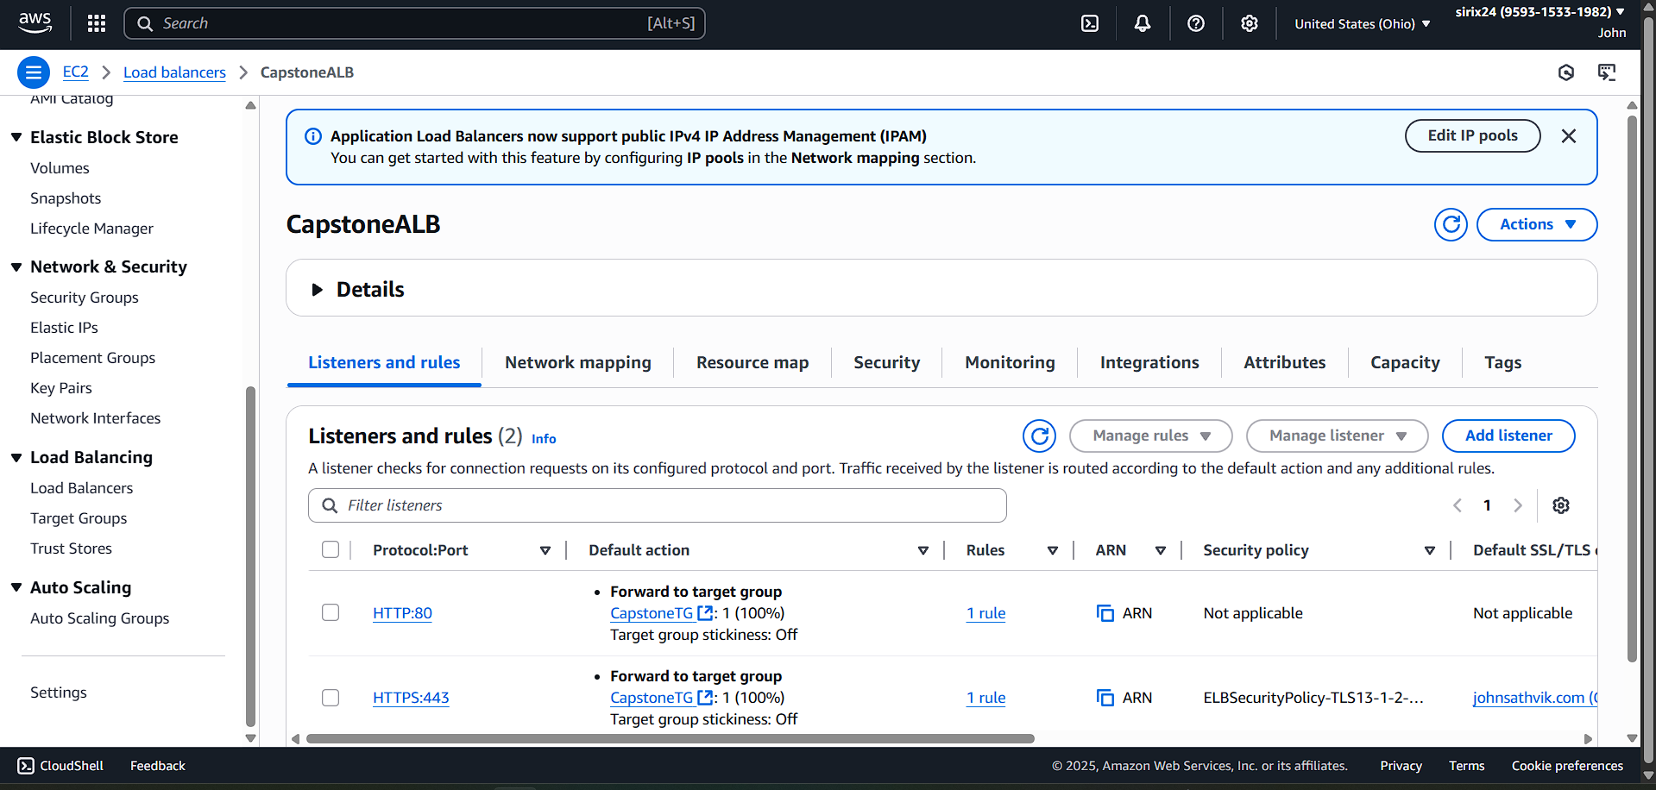

* Created and configured a hosted zone in Amazon Route 53 to manage custom domain DNS records and enable reliable routing of application traffic.

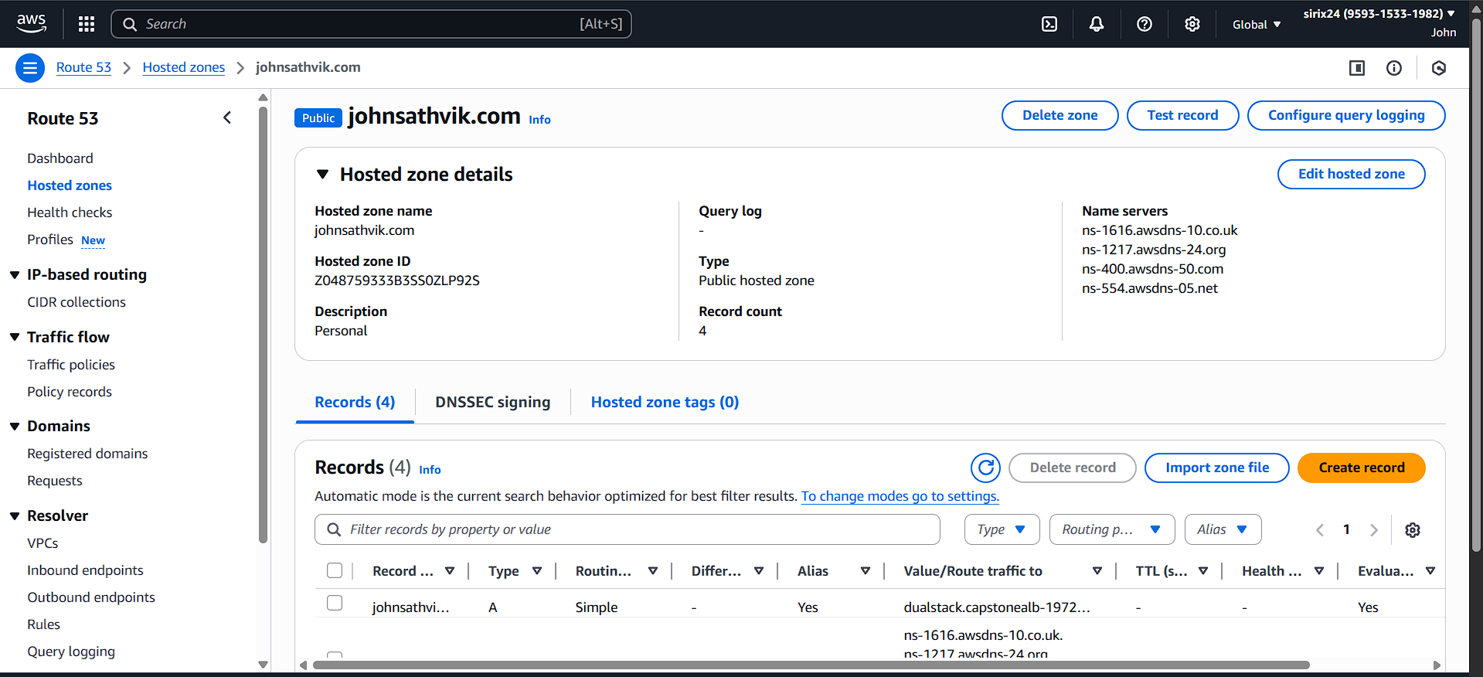

* Provisioned and validated SSL/TLS certificate in AWS Certificate Manager for domain johnsathvik.com

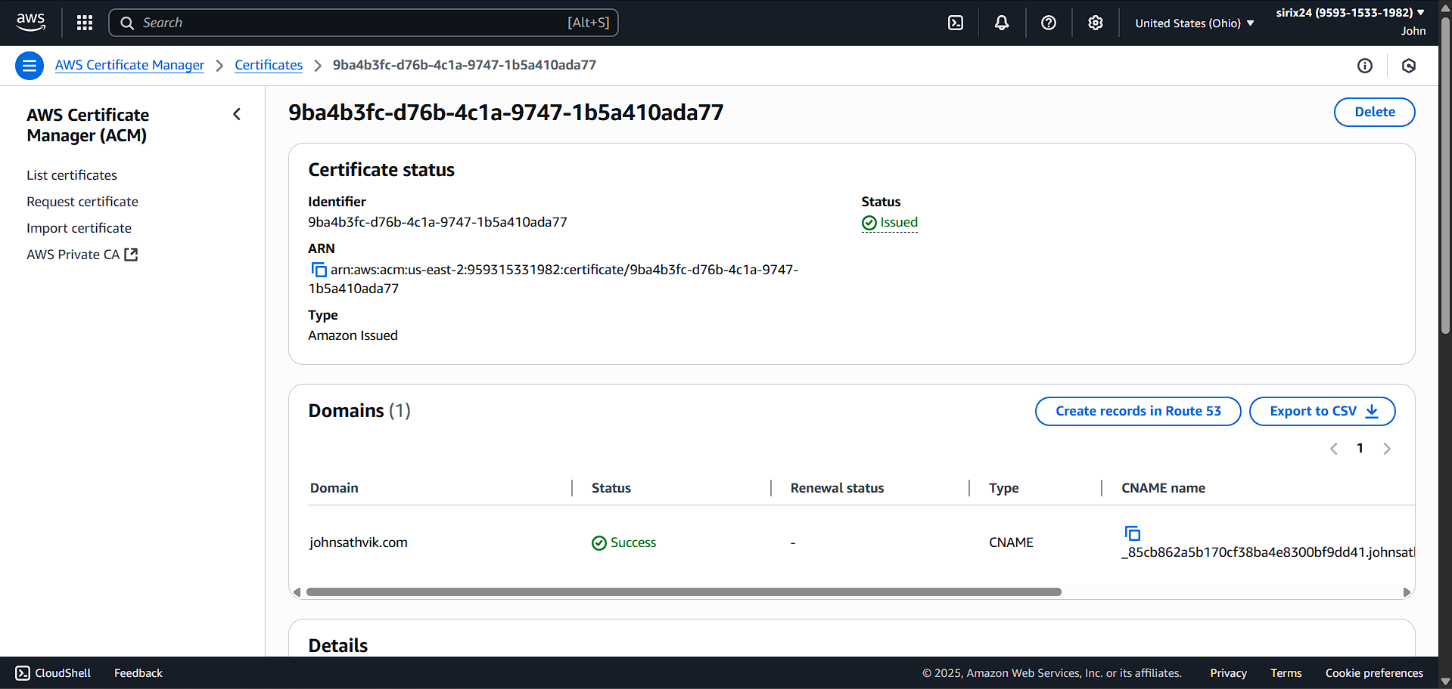

* Configured Amazon EventBridge rule to send alerts on EC2 instance state changes.

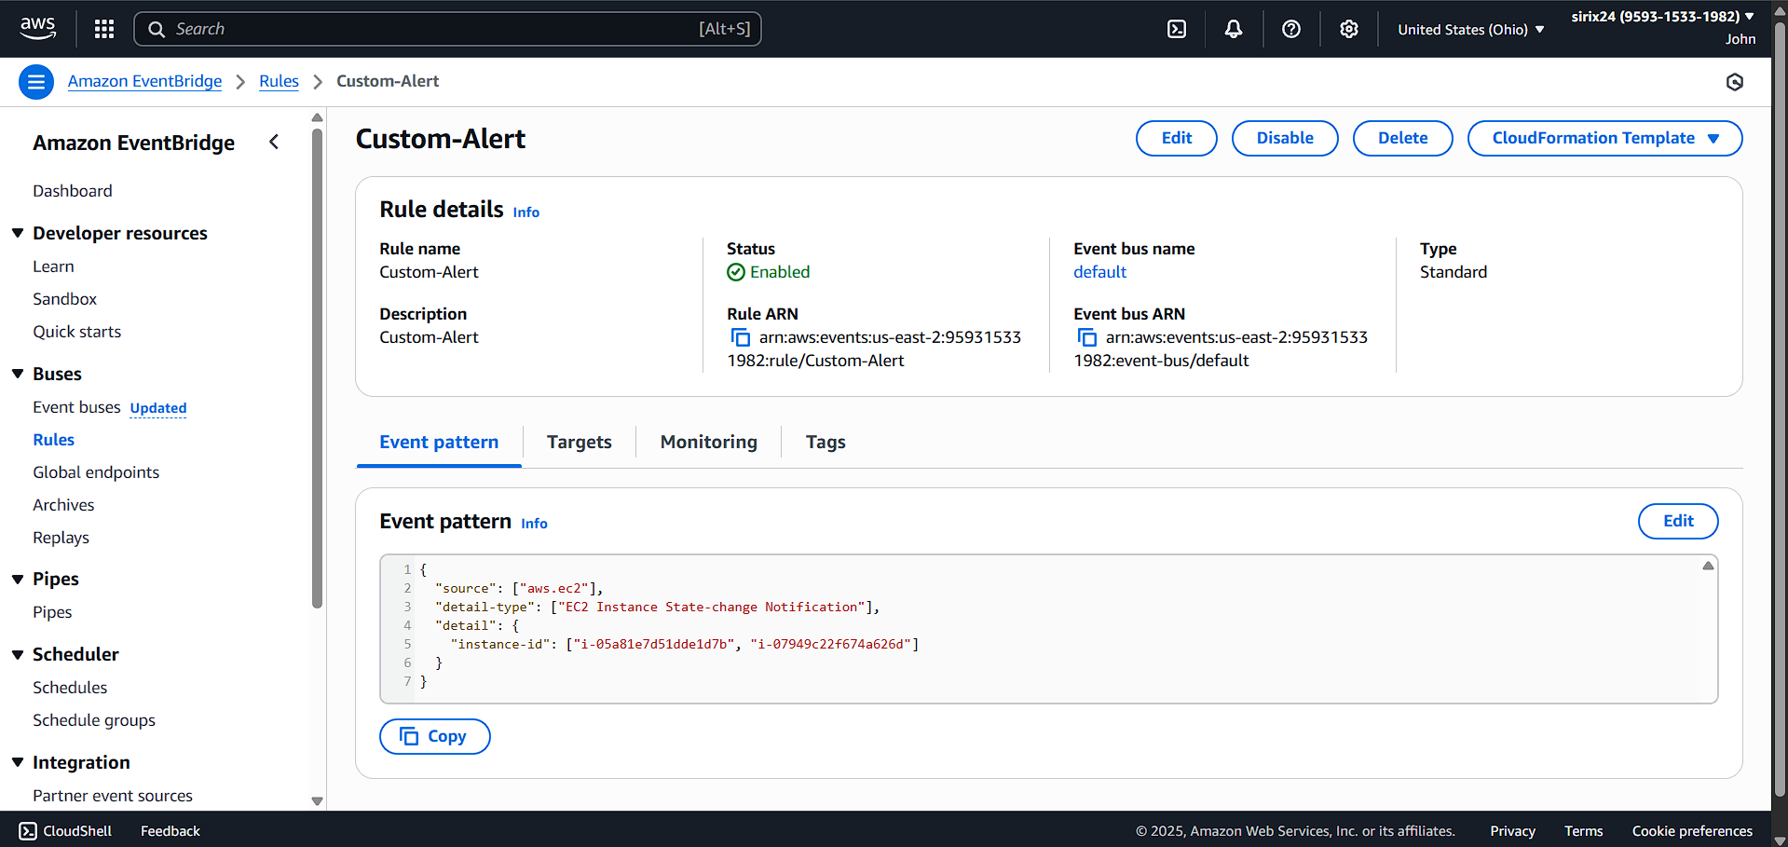

* Created Amazon SNS topic and subscription to receive notifications when EC2 instance CPU utilization exceeds 80%.

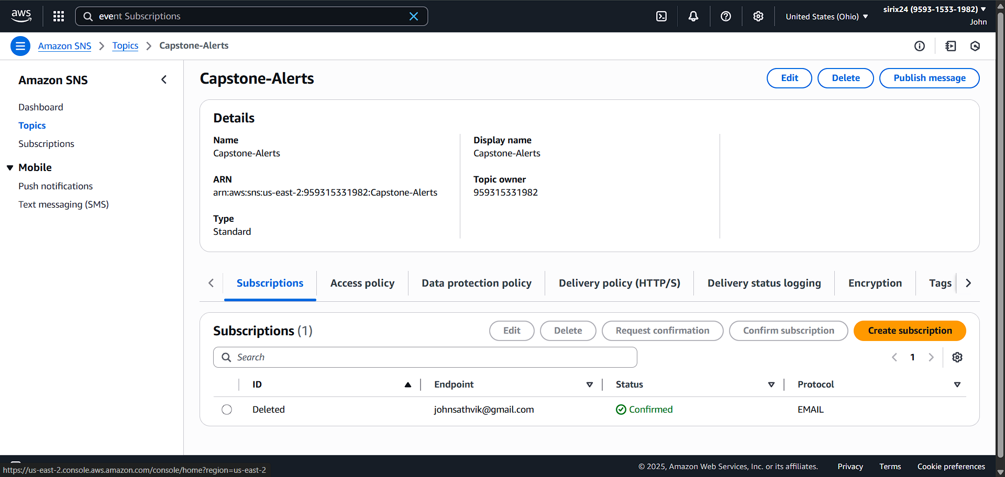 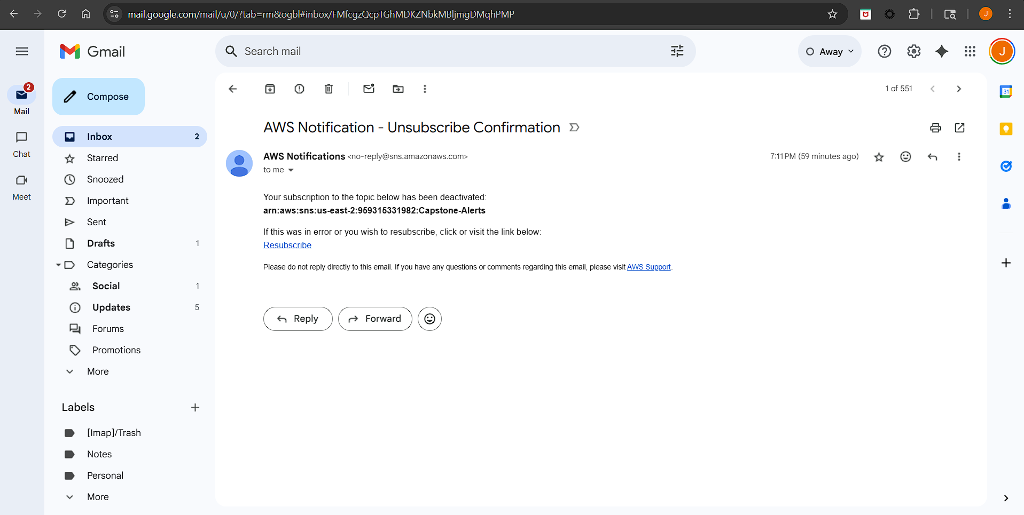

**Output**

